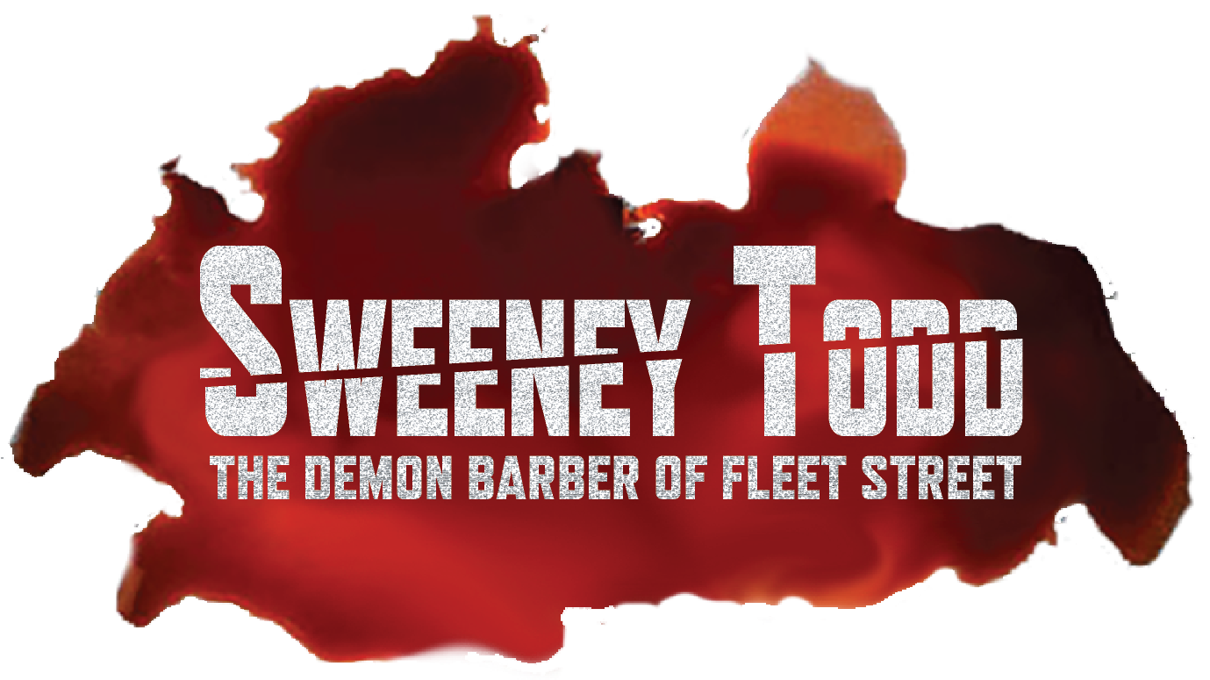
POSITION INFORMATION FORM
The information below will be used for casting and for future reference during the rehearsal process.
None of this information will be released to the public. Please type or print.
Last Name: First Name:
Year at Carroll: 1st 2nd 3rd 4th 5th Alumni My Pronouns:
Cell Number: CU Email:
Student ID Number: Non-CU Email for Alumni:
· If you are hired, is on-campus housing a necessity for you from May 31 – July 28? YES NO
· I’m interested in 1-2cr of THE490 (a letter grade) for participating, and understand registering for 1cr is the only way to receive free Housing from May 31 – July 28: YES NO MAYBE

· T-Shirt size: XS SM MED L XL XXL XXXL

TIME COMMITMENT
Rehearsals: Evenings or afternoons MTWR and some Fridays; (May 31 – July 11)
Tech Week: 6-10pm SuMTWR (Sun July 14 – Wed July 17)
Performances: Thursday, July 18 – Sunday, June 21 & Friday, July 26 – Saturday, July 27
(Exact performance dates/times TBD at this time)

Please put an ‘X’ during times that YOU ARE NOT available Fri May 31 – Fri July 12)
 | Monday | Tuesday | Wednesday | Thursday | Friday
10am
11am
12pm
1pm
2pm
3pm
4pm
5pm
6pm
7pm
8pm
9pm

BIG NOTES:

- Tech Week is Sun, July 14 – Thurs, July 18 – NO CONFLICTS will be allowed this week 5-10pm!
****I understand no conflicts are allowed 5-10pm on Sunday, July 14 – Thursday, July 18, and through both performance weekends. YES
List other conflicts that you have between May 31 – June 28 (travel, conferences, CCE, org events, exams, etc):
NOTE: Rehearsal will not take place on Thursday July, 4 or Friday, July 5.

B) Summer Rep is an ‘all-hands-on-deck’ experience in which everyone is called to assist with all aspects of the production when necessary. That includes helping in the Shops.
· I consent to possible COVID-19 testing weekly during the rehearsal process and daily during tech/performances:
YES NO

Signature: __________________________________________________ Date: ___________________

SWEENEY TODD COMPANY MEMBER COMFORT SURVEY
This survey is designed to gauge your comfort level with various aspects of SWEENEY TODD. Note that these answers are not binding, and consent will be monitored closely throughout the production process, as consent can always be retracted. Please answer as honestly as possible, knowing that much consent and boundary work will be completed as part of the production process. Some directorial changes will be made where words or stage directions may be harmful to our Ethos or community (use of specific lyrics, etc.)

Are you comfortable participating in this ‘horror’ genre musical, which includes the creation of a ton of blood and gore?!
YES NO MAYBE (when understanding boundaries, and intention)

Comments:

Are you comfortable participating in content-warning subject matter, as it appears in both the libretto and score? (murder, violence, kidnapping, death, stalking, sexual innuendo, forced institutionalization, mental illness, cannibalism)
YES NO MAYBE (when understanding boundaries, blocking, and intention)

Comments:

Are there any concerns you have that may not be represented here? Please feel free to comment/ask questions below.

CARROLL UNIVERSITY THEATRE PROGRAM CODE OF EXPECTATIONS
Theatre, Musical Theatre, Arts Management, Dance, Film and Television
“Disrespectful behavior, sexual harassment, sexual misconduct, and systemic bullying are deeply embedded in our culture –and are contrary to who we are and what we aspire to be.
Theatre is an art form. The work can and should be challenging, experimental, exploratory, and bold. Artistic freedom of expression is essential. For these things to happen, though, the creative space must be a safe space. And because the spaces in which we work are broad – encompassing administration, auditions, rehearsals, technical work, late nights, parties, public-facing frontline work, and more – we must acknowledge, and not exploit, the blurred boundaries between work and social spaces.”
(The Public Theater’s Code of Conduct)
______________________________________________________________________________
Carroll University’s Theatre Program is committed to providing a healthy and respectful environment for everyone involved in our courses and productions, and our expectation is that everyone involved will support that commitment through their own actions and language. The Theatre Program honors Carroll’s Ethos Statement: Respect, Integrity, and Stewardship.
To that end, we have created the following Code of Expectations to provide you with guidelines on appropriate behaviors, etiquette, and information on theatrical production processes overall at Carroll.
SELF-REFLECTION AND PERSONAL RESPONSIBILITY ARE REQUIRED FOR ALL ARTISTS.
We all must be able to hear and recognize the impact of our own actions. When we receive feedback that we have (even unintentionally) made someone uncomfortable or made someone feel disrespected, we commit to looking inward, becoming more self-aware, and adjusting any offensive behavior immediately. Cooperation and an open mind are expected if we are approached about any offensive behavior.
WHAT DOES DISRESPECTFUL BEHAVIOR LOOK LIKE?
The list of potentially inappropriate behaviors below is not all-inclusive, but is meant to provide you with examples.
- Multiple instances/reports of the below types of conduct issues may result in dismissal from productions, projects, leadership positions, or employment positions.
- Carroll University Student Conduct or other appropriate University constituents may be alerted (Title IX, Dean of Students, etc.)

HARASSMENT AND BULLYING WILL NOT BE TOLERATED
Harassment is when someone is made to feel unsafe. Unwelcome conduct can be verbal,
written, physical (sexual/aggressive) or even through looks, gestures, or other unwanted acts.
Bullying is intentionally and repetitively making people feel vulnerable, ashamed, or marginalized.
PHYSICAL CONTACT AND PHYSICAL ATTENTION – RESPECT BOUNDARIES WITHOUT QUESTION
▪ If in doubt, don’t touch someone. If someone pulls away or asks you to stop, even if the physical touch is associated with blocking or choreography – STOP. Respect boundaries without question.

- Each production/project process will begin with a Consent and Boundary-Practices Workshop to create common language and intention regarding physical boundaries.

▪ Privacy is essential, especially in regard to dressing rooms, costume fittings, quick costume changes, etc.
- There is never a need to observe the above activities, unless you have been assigned a crew position or are assisting a Costume Designer directly.
- Private dressing areas can always be created backstage – please let the Director or Stage Manager know if you need one.

▪ If you do not want someone paying attention to you, clearly communicate that to them. If someone does not want you paying attention to them, respect their boundary. Respect boundaries without question.

USE OF RESPECTFUL LANGUAGE IS IMPORTANT
▪ “No one should be subject to a judgmental gaze or commentary on clothing, bodies, racial attributes, weight, physical characteristics, or personality characteristics.” (Public Theatre’s Code of Conduct)
▪ A persons’ pronouns, requested name, or other identity-marking language should always be respected.
▪ Voicing assumptions about gender, sexuality, race, or religion is disrespectful. o Asking questions in order to gain understanding is acceptable and welcomed, but you’re encouraged to ask questions outside of the rehearsal room.
- Respect if someone does not want to discuss their gender, sexuality, race, or religion with you.

▪ Public outbursts and public/online shaming are threatening and have absolutely no place at Carroll University or in the greater Theatre community/industry.

REHEARSAL ETTIQUETE – BE PREPARED, PROFESSIONAL + DON’T TAKE THINGS PERSONALLY!
▪ Always bring your script/production materials to rehearsal, along with a pencil.
- Write down all blocking, music notes, and acting notes into your script when they are first given to you.
▪ Do not leave the Theatre/rehearsal space without permission from the Stage Manager. If your permission is denied, respect that denial and remain in the space. Periodic breaks will be given for eating, drinking, checking phones, etc. You may absolutely ask a Stage Manager when the next break will occur, and will always be given a break for emergencies. o If you aren’t being engaged in rehearsal for an extended period of time, you can study elsewhere in the building, or quietly in the rehearsal room. Always let the Stage Manager know where you’ll be in case you’re needed.
- If you have health or medical-related issues, please be sure to inform the Director and Stage Manager. Note that the Theatre Program cannot be responsible for having supplies (food, drink, medication, etc.) on hand for medical-related conditions. There is a refrigerator in the Green Room if you need to store consumable items or medications – ask the Stage Manager for access.
- If you are injured during the rehearsal or production process, ice packs will be available from the Stage Manager, along with general first aid items from the Lobby or Scene Shop First Aid boxes. You may be asked to complete an Accident Report form, based on the injury sustained.

▪ When calling for a line, don’t feel the need to apologize. Simply call “Line” and a Stage Manager or ASM will start saying your line for you. They will continue speaking the line until you jump in and begin to speak it yourself. o Not ready to be off book, and afraid the amount of times you’ll need to call for line may slow down a rehearsal or run-through? Speak with the Director or Stage Manager and request to have your script with you.
- And, plan to be prepared for the next rehearsal.

▪ Interrupting or talking over Directors, Choreographers, Stage Managers, or others during rehearsals is disrespectful and will not be tolerated.

▪ If you have a question during rehearsal, please be cognizant that multiple questions can disrupt rehearsal and slow down the overall production process. Is it necessary to have the question answered in this moment? Is the question specifically about you/your character/your blocking, and would it potentially not benefit the group currently in the rehearsal room? Is it a question better served for the Stage Manager, or on a break?

- A notepad will be backstage at all times where questions/comments can be left for Directors/Stage Managers. Stage Managers will check the notepad nightly and communicate necessary items to the Director/Production Team.
- If you have an important question that needs to be answered in the moment, please raise your hand. A Director may take your question, or let you know when time for questions will occur.

- Stage Managers will record all blocking – if you have a question or miss a blocking rehearsal, ask the SM when they can meet with you to ensure you have your blocking.

- Dance Captains are assigned to help actors with choreography outside of rehearsals. Ask a Dance Captain when they can meet with you if you have questions or need support. Most of the time, videos of choreography will be made so actors can always reference choreography.

▪ ‘Suggestions’ for improvement in things like blocking or choreography should not be voiced unless you are specifically asked for your opinion or assistance. If you are asked for a suggestion or opinion and it is not ultimately taken, please don’t take it personally. Remember, the Director has an overall vision for the production.
▪ Actors should never give each other ‘notes,’ in any circumstance. Directors will let participants know who they determine can give actor notes (usually Stage Managers, Choreographers, and Dance Captains.) o The best way to receive a note is to say “thank you,” write it down, and then attempt to implement it the next time you work that scene.
- If you do not understand a note, ask for clarification. Directors and choreographers may make multiple changes throughout a rehearsal process, and sometimes may also forget or misremember notes or blocking they’ve given you in the past. It is definitely okay to ask for clarification if/when things change, but please attempt to implement notes and trust a Directors’/Choreographers’ vision.
- A Director or Choreographer should not have to give you the same note more than once.
- Please do not take notes personally! Notes will be given in a respectful manner, with intention to improve the production’s vision and quality, not to belittle an actor.

▪ The Green Room will be used as a “Quiet Space” before and during rehearsals. All actors have different processes, so please be mindful and respectful if actors do not want to interact prior to, during, or on breaks, and please keep your voice/music down near the Green Room.

▪ NOTE on class absences: If you miss any of your THE/DNC classes the day of any rehearsal or performance, you cannot attend that day’s rehearsal or performance.

REPORTING PROCESS/STRUCTURE:

Report any concerns/issues immediately to the production’s Stage Manager.

If you do not feel comfortable reporting to the Stage Manager, you can report to either the production’s Director or a Theatre Program Faculty Member (Dobby, Gale, Kuenn, Zager.)

If you do not feel comfortable reporting to any of those mentioned above, you can reach out via email to Jake Eisch, jeisch@carrollu.edu, who oversees Student Conduct, or to Dean Kareem Muhammad
(kmuhamma@carrollu.edu), who oversees Faculty/Staff Conduct issues for the College of Arts and Sciences.

This Code of Expectations is a living document and will be periodically updated.

I acknowledge understanding of the aforementioned terms and expectations:

__________________________
NAME

_________________________
DATE

